Crystal Reports for .NET Framework 2.0
Deployment Using Merge Modules

Overview

This document provides a detailed description of how to perform a deployment using the Crystal Reports for .NET Framework 2.0 merge modules.

System Requirements 2
Dependencies 2
Walkthroughs 3
X86 Deployments 3
IA64 Deployments 5
X64 Deployments 7

System Requirements
System | .msm File
x86 (32bit) | CrystalReportsRedist2005_x86.msm
IA64 (64bit) | CrystalReportsRedist2005_ia64.msm
x64 (64bit) | CrystalReportsRedist2005_x64.msm

Dependencies
When deploying your system using the Crystal Reports for .NET Framework 2.0 merge modules, please ensure that the following dependency files are available in the \Program Files\Common Files\Merge Modules folder. Without these dependency files in place, the setup will fail.

System | .msm File
x86 (32bit) | Microsoft_VC80_ATL_x86.msm
x86 (32bit) | policy_8_0_Microsoft_VC80_ATL_x86.msm
IA64 (64bit)* | Microsoft_VC80_ATL_x86_ia64.msm
IA64 (64bit)* | Microsoft_VC80_CRT_x86_ia64.msm
IA64 (64bit)* | Microsoft_VC80_MFC_x86_ia64.msm
IA64 (64bit)* | policy_8_0_Microsoft_VC80_ATL_x86_ia64.msm
IA64 (64bit)* | policy_8_0_Microsoft_VC80_CRT_x86_ia64.msm
IA64 (64bit)* | policy_8_0_Microsoft_VC80_MFC_x86_ia64.msm
x64 (64bit)* | Microsoft_VC80_ATL_x86_x64.msm
x64 (64bit)* | Microsoft_VC80_CRT_x86_x64.msm
x64 (64bit)* | Microsoft_VC80_MFC_x86_x64.msm
x64 (64bit)* | policy_8_0_Microsoft_VC80_ATL_x86_x64.msm
x64 (64bit)* | policy_8_0_Microsoft_VC80_CRT_x86_x64.msm
x64 (64bit)* | policy_8_0_Microsoft_VC80_MFC_x86_x64.msm

*To obtain the required dependency files, users must ensure that the “Itanium Compilers and Tools” and “X64 Compilers and Tools” check-boxes are checked before installing Visual Studio. (Note that these boxes are unchecked by default.)
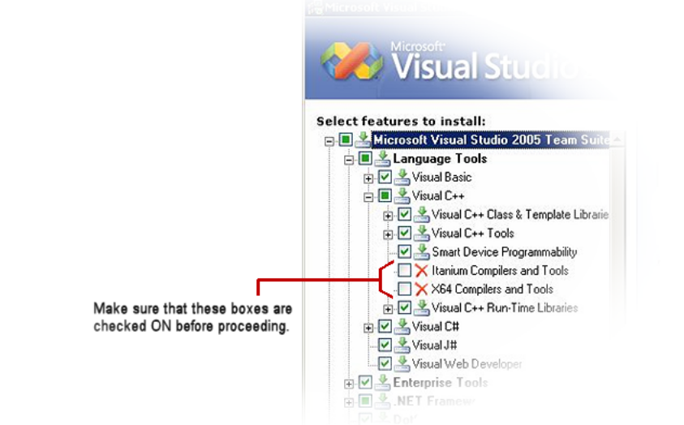

Note: 64-bit compilers and tools are only available with the following editions: Visual Studio Professional Edition (contains X64 Compilers and Tools only), Visual Studio Team System, Visual Studio Test Tools, Visual Studio Tools for Applications, and Visual Studio Team edition for Developers.

Walkthroughs

X86 Deployments
- Copy CrystalReportsRedist2005_x86.msm to the \Program Files\Common Files\Merge Modules folder.
- Start Visual Studio.
- In the File menu, select New|Project.
- In the “New Project” dialog box, select a Windows Setup Project or a Web Setup Project.
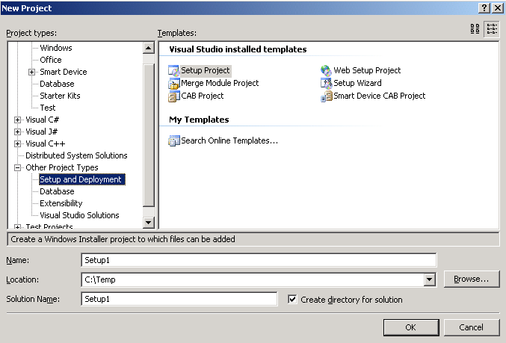
- In the “Solution Explorer”, select your setup project, right-click, and select Add|Merge Module from the pop-up menus:
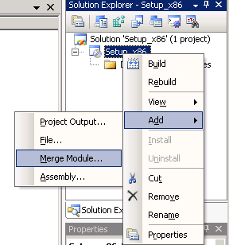

- Add CrystalReportsRedist2005_x86.msm to your project:
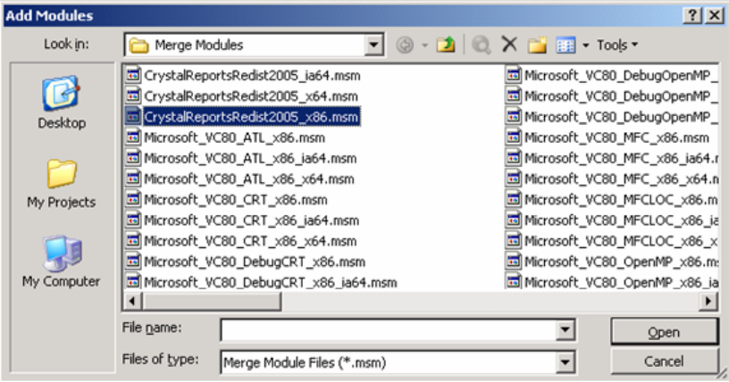
Note that Microsoft_VC80_ATL_x86.msm and policy_8_0_Microsoft_VC80_ATL_x86.msm will be automatically included when you add CrystalReportsRedist2005_x86.msm to your project:

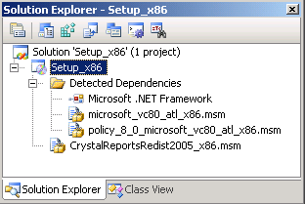

- Build your project.
- Run your deployment setup.

IA64 Deployments
- Copy CrystalReportsRedist2005_ia64.msm to the \Program Files\Common Files\Merge Modules folder.
- Start Visual Studio.
- In the File menu, select New|Project.
- In the “New Project” dialog box, select a Windows Setup Project or a Web Setup Project.

- In the “Solution Explorer”, select your setup project, right-click, and select Add|Merge Module from the pop-up menus:
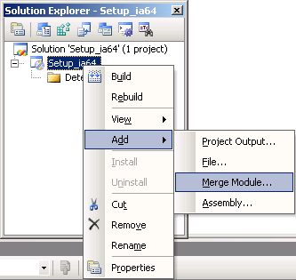

- Add CrystalReportsRedist2005_ia64.msm to your project:
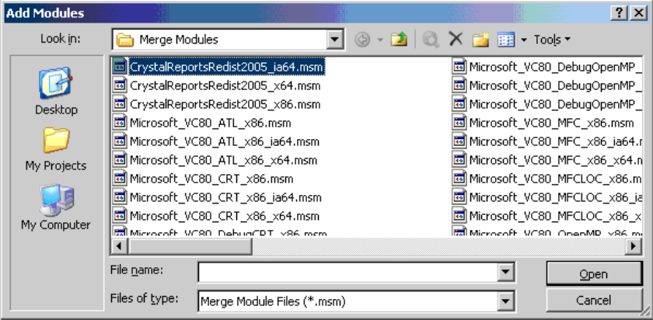

Note that the following files are automatically included when you add CrystalReportsRedist2005_ia64.msm to your project:

- Microsoft_VC80_ATL_x86_ia64.msm
- Microsoft_VC80_CRT_x86_ia64.msm
- Microsoft_VC80_MFC_x86_ia64.msm
- policy_8_0_Microsoft_VC80_ATL_x86_ia64.msm
- policy_8_0_Microsoft_VC80_CRT_x86_ia64.msm
- policy_8_0_Microsoft_VC80_MFC_x86_ia64.msm
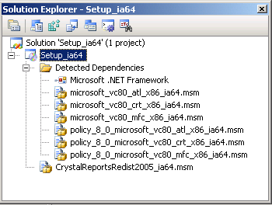
- In the “Properties” dialog box, set your TargetPlatform to “Itanium”:
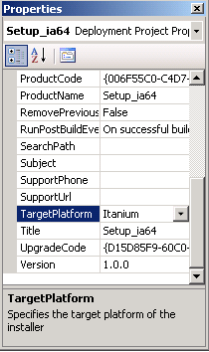
- Build your project.
- Run your deployment setup.

X64 Deployments
- Copy CrystalReportsRedist2005_x64.msm to the \Program Files\Common Files\Merge Modules folder.
- Start Visual Studio.
- In the File menu, select New|Project.
- In the “New Project” dialog box, select a Windows Setup Project or a Web Setup Project.

- In the “Solution Explorer”, select your setup project, right-click, and select Add|Merge Module from the pop-up menus:
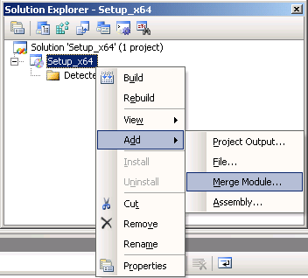
- Add CrystalReportsRedist2005_x64.msm to your project:
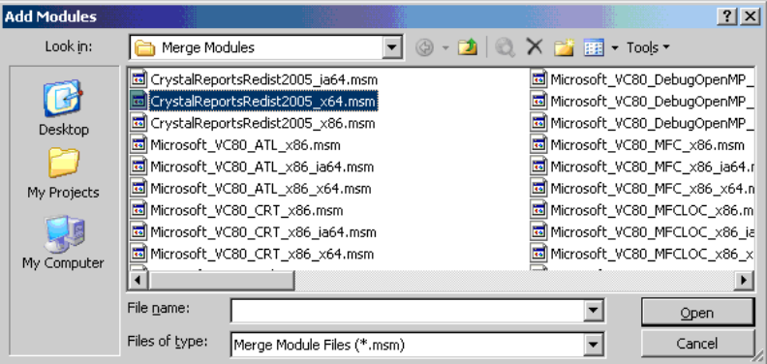
Note that the following files are automatically included when you add CrystalReportsRedist2005_x64.msm to your project:

- Microsoft_VC80_ATL_x86_x64.msm
- Microsoft_VC80_CRT_x86_x64.msm
- Microsoft_VC80_MFC_x86_x64.msm
- policy_8_0_Microsoft_VC80_ATL_x86_x64.msm
- policy_8_0_Microsoft_VC80_CRT_x86_x64.msm policy_8_0_Microsoft_VC80_MFC_x86_x64.msm
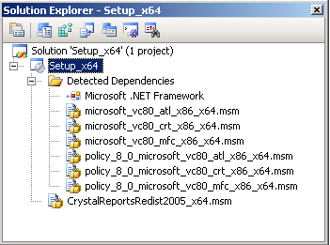
- In the “Properties” dialog box, set your TargetPlatform to “x64”
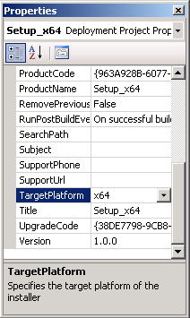
- Build your project.
- Run your deployment setup.

